|  |  |
| --- | --- |
| **EXP NO: 1** | **AZURE DEVOPS ENVIRONMENT SETUP** |

**Aim:**

To set up and access the Azure DevOps environment by creating an organization through the Azure portal.

**INSTALLATION**

1.Open your web browser and go to the Azure website: https://azure.microsoft.com/enus/get started/azure-portal.

Sign in using your Microsoft account credentials.

If you don't have a Microsoft account, you can create one here:

<https://signup.live.com/?lic=1>

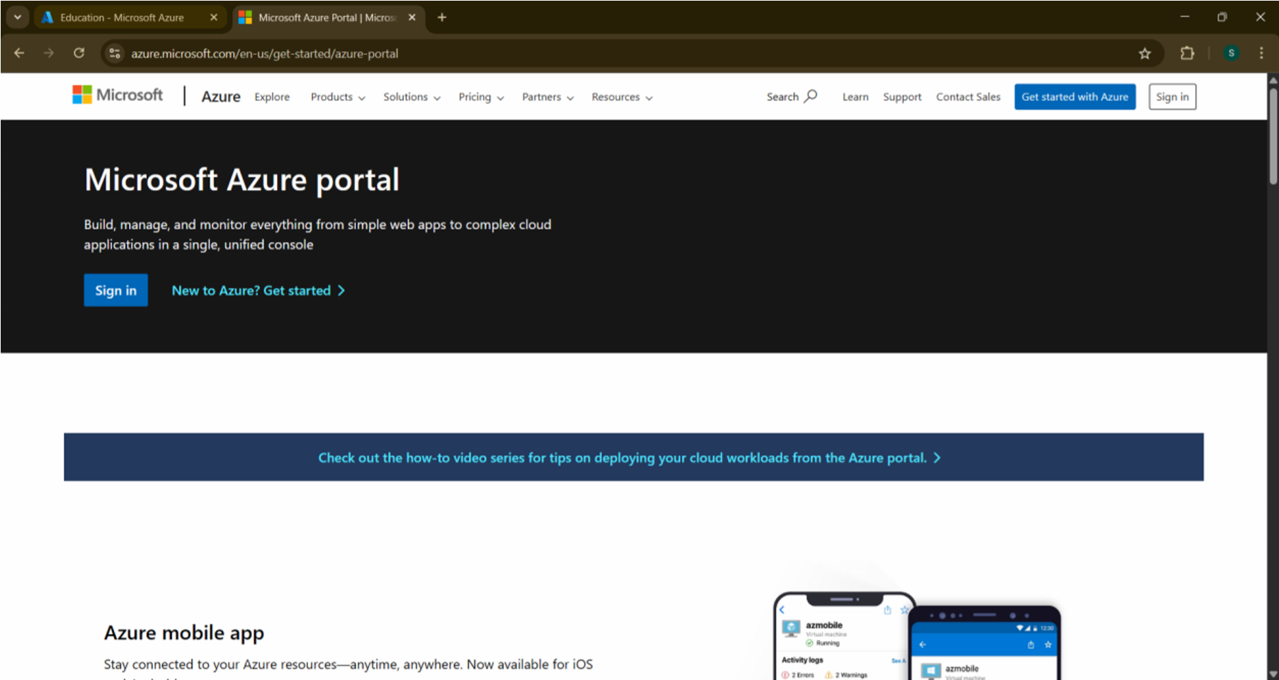

2.Azure home page

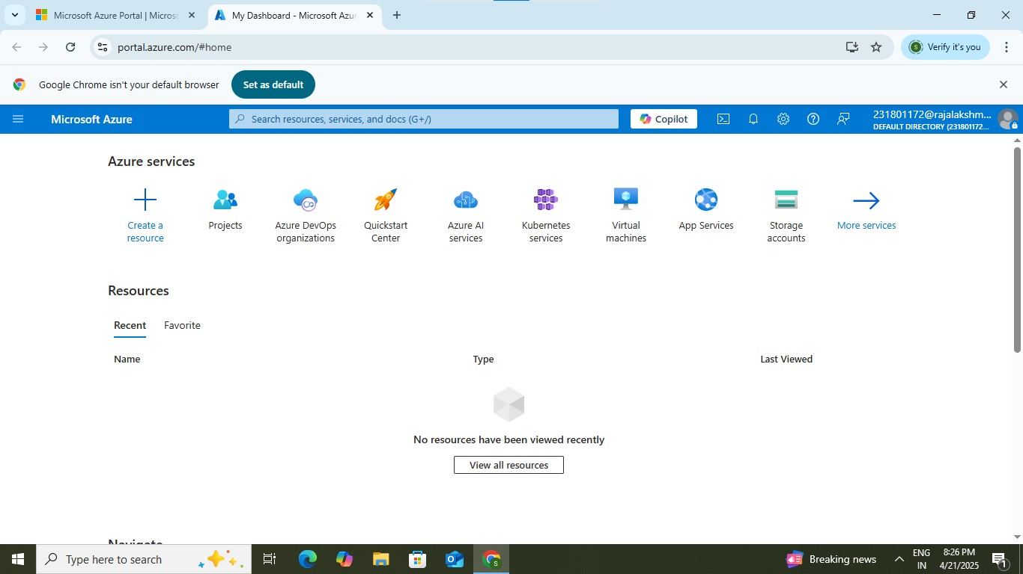

3.Open DevOps environment in the Azure platform by typing Azure DevOps Organizations in the search bar

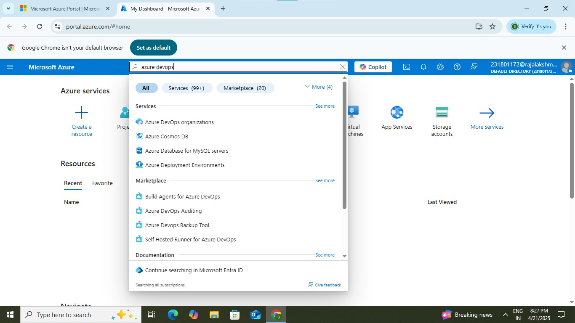

4.Click on the My Azure DevOps Organization link and create an organization and you should be taken to the Azure DevOps Organization Home page.

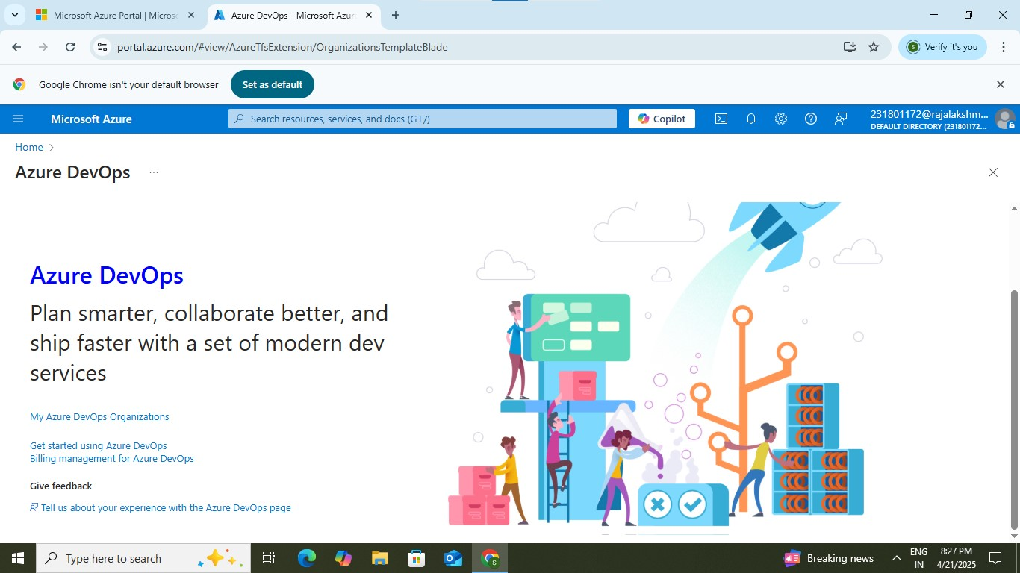

**RESULT: Successfully accessed the Azure DevOps environment and created a new organization through the Azure portal.**

|  |  |  |  |  |  |
| --- | --- | --- | --- | --- | --- |
| **EXP NO: 2** |  | | | | |
|  | **AZURE DEVOPS PROJECT SETUP AND USER STORY** | | |  |
|  | **MANAGEMENT** |  |

**Aim:**

To set up an Azure DevOps project for efficient collaboration and agile work management.

1.Create An Azure Account

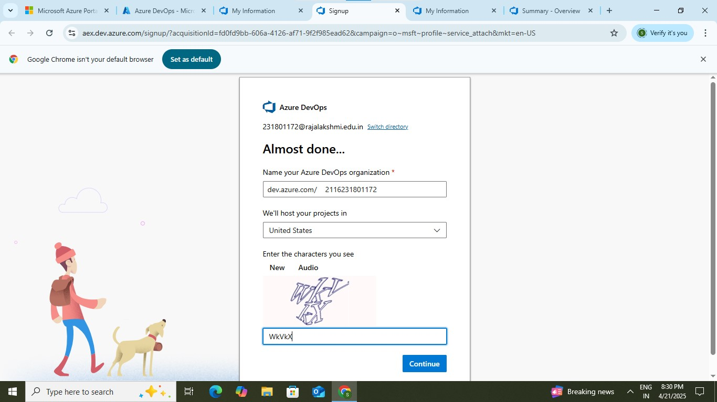

2.Create the First Project in Your Organization

1. After the organization is set up, you’ll need to create your first **project**. This is where you'll begin to manage code, pipelines, work items, and more.
2. On the organization’s **Home page**, click on the **New Project** button.
3. Enter the project name, description, and visibility options:

**Name**: Choose a name for the project (e.g., LMS).

**Description**: Optionally, add a description to provide more context about the project.

**Visibility**: Choose whether you want the project to be **Private** (accessible only to those invited) or **Public** (accessible to anyone).

1. Once you’ve filled out the details, click **Create** to set up your first project.

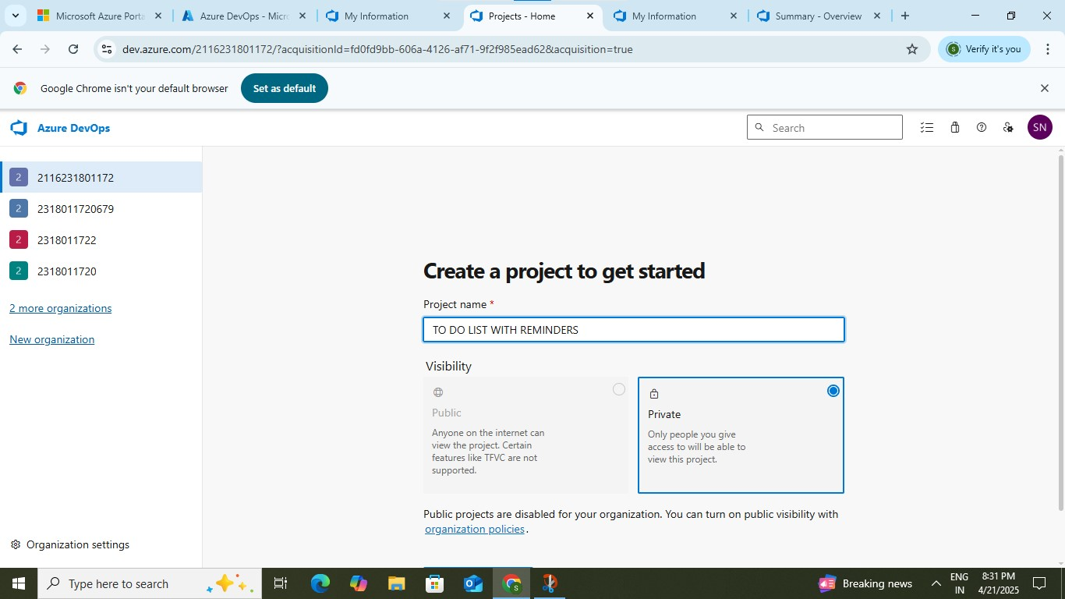

3.Once logged in, ensure you are in the correct organization. If you're part of multiple organizations, you can switch between them from the top left corner (next to your user profile). Click on the Organization name, and you should be taken to the Azure DevOps Organization Home page.

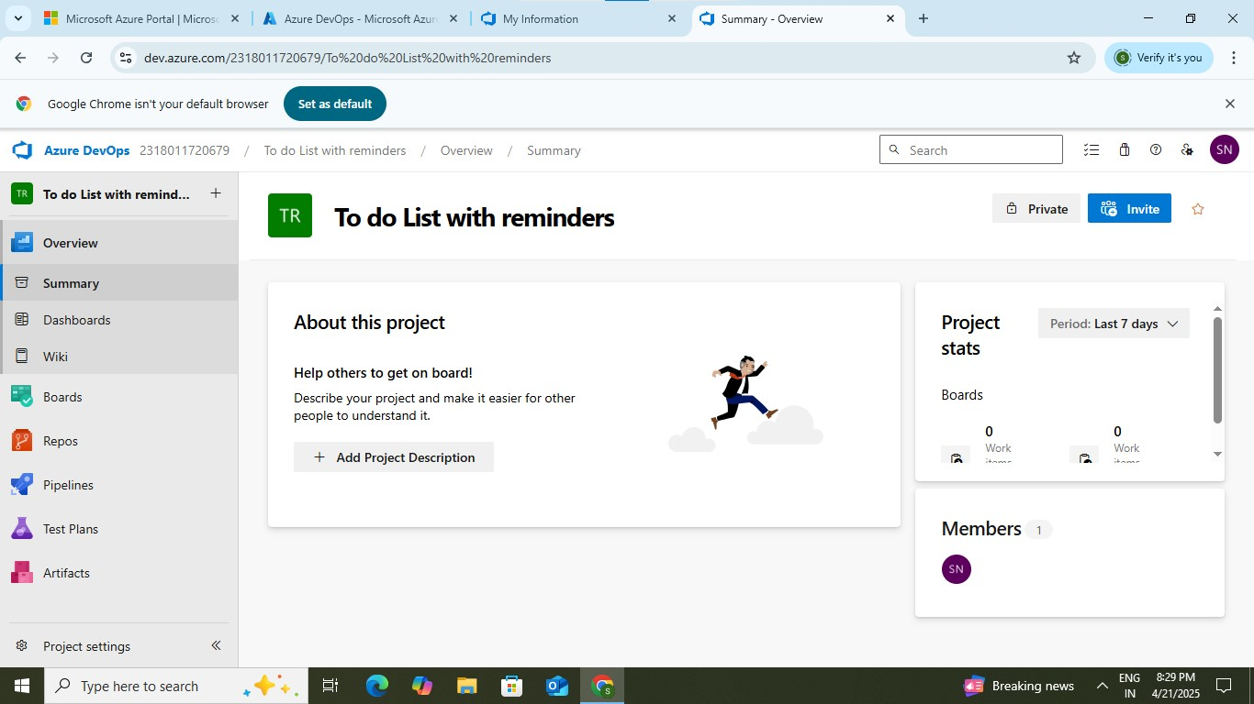

4.Project dashboard

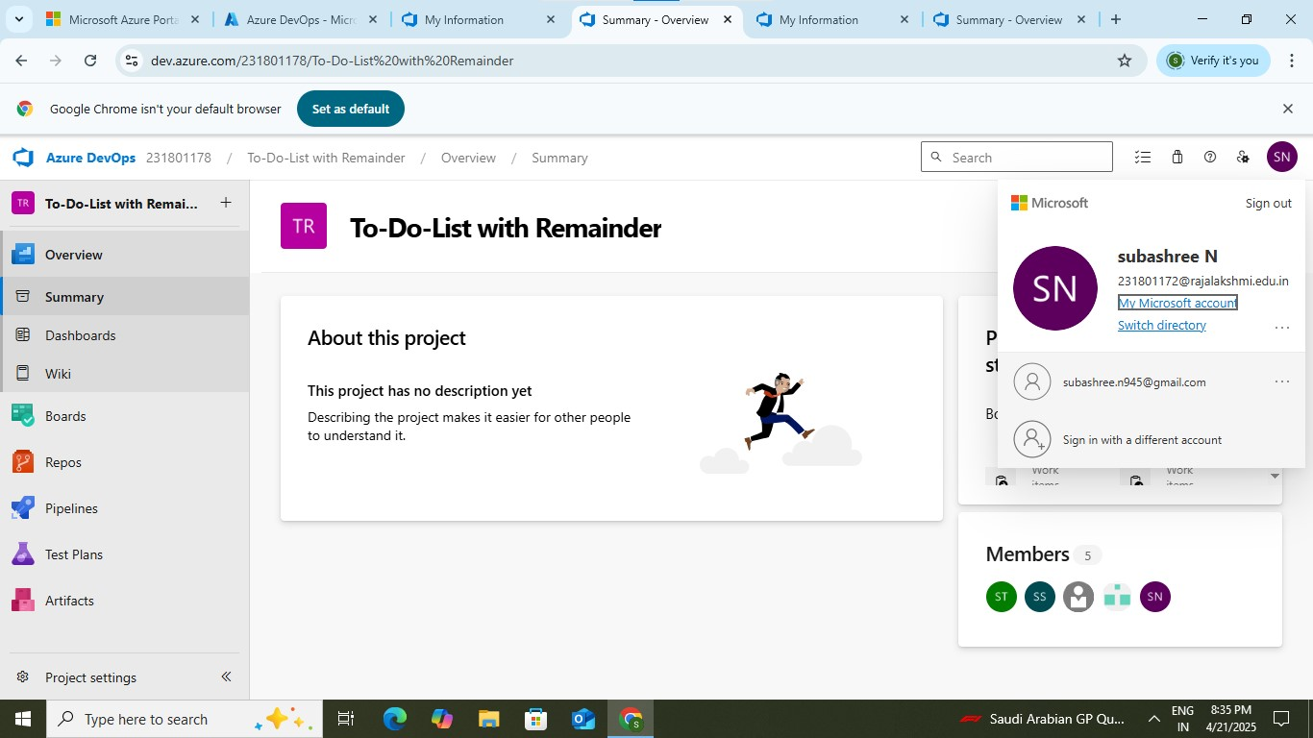

5.To manage user stories:

a.From the **left-hand navigation menu**, click on **Boards**. This will take you to the main **Boards** page, where you can manage work items, backlogs, and sprints.

b.On the **work items** page, you'll see the option to **Add a work item** at the top. Alternatively, you can find a + button or **Add New Work** **Item** depending on the view you're in. From the **Add a work item** dropdown, select **User Story**. This will open a form to enter details for the new User Story.

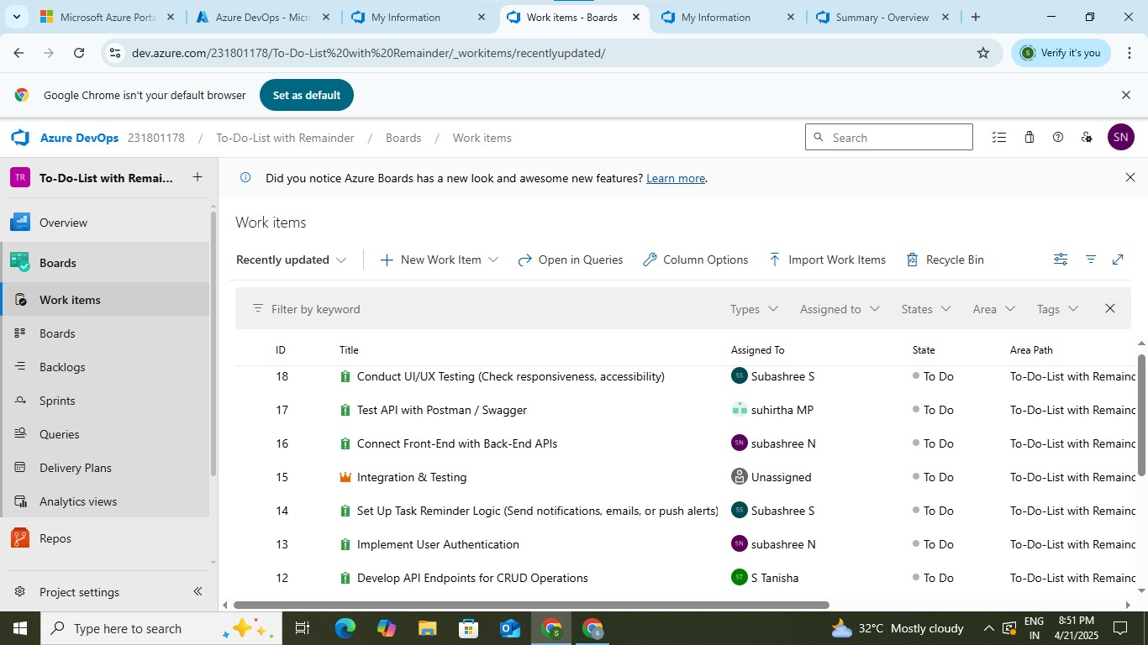

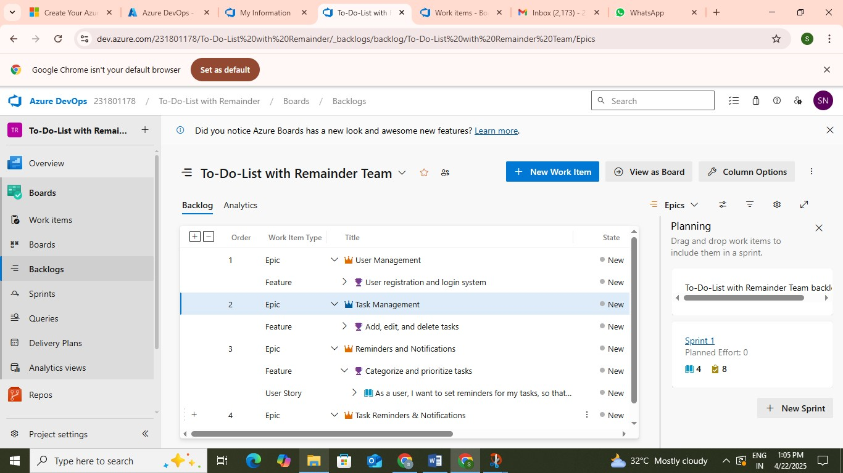

**Result:**  **successfully created an Azure DevOps project with user story management and agile workflow setup.**

|  |  |  |  |  |  |
| --- | --- | --- | --- | --- | --- |
| **EXP NO: 3** |  | | | | |
|  | **SETTING UP EPICS, FEATURES, AND USER STORIES FOR** | | |  |
|  | **PROJECT PLANNING** |  |

**Aim:**

To learn about how to create epics, user story, features, backlogs for your assigned project.

**Create Epic, Features, User Stories, Task**

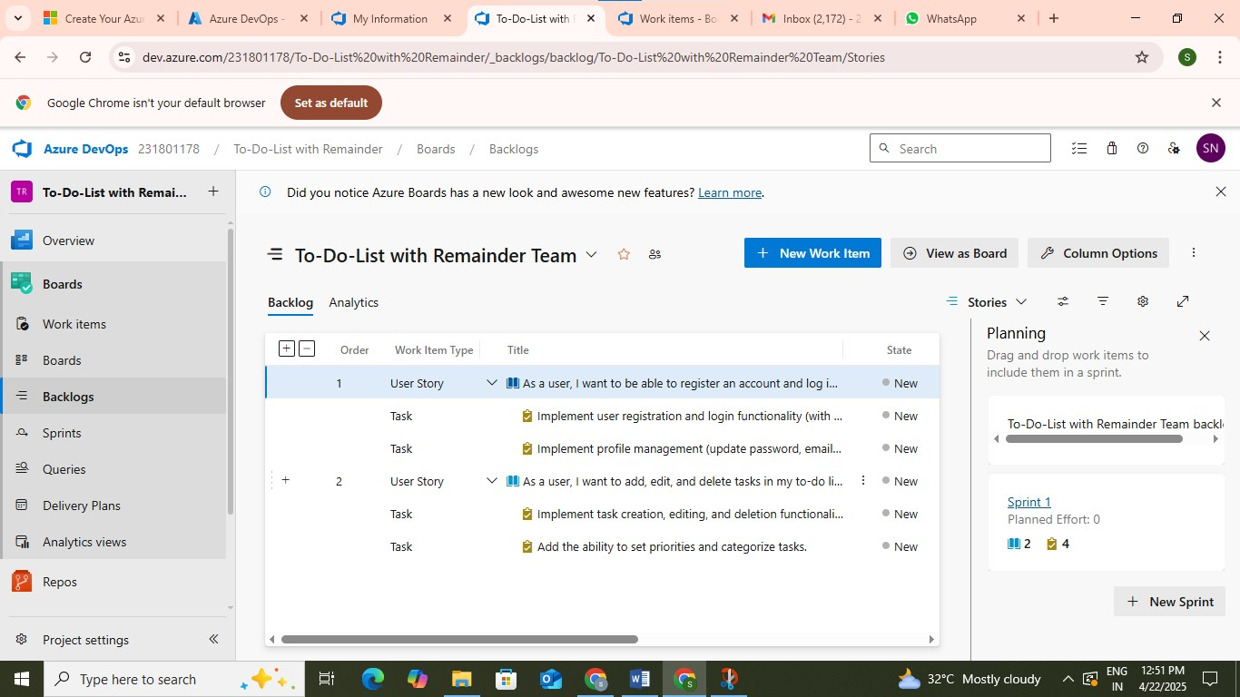

**1.Fill in Epics** 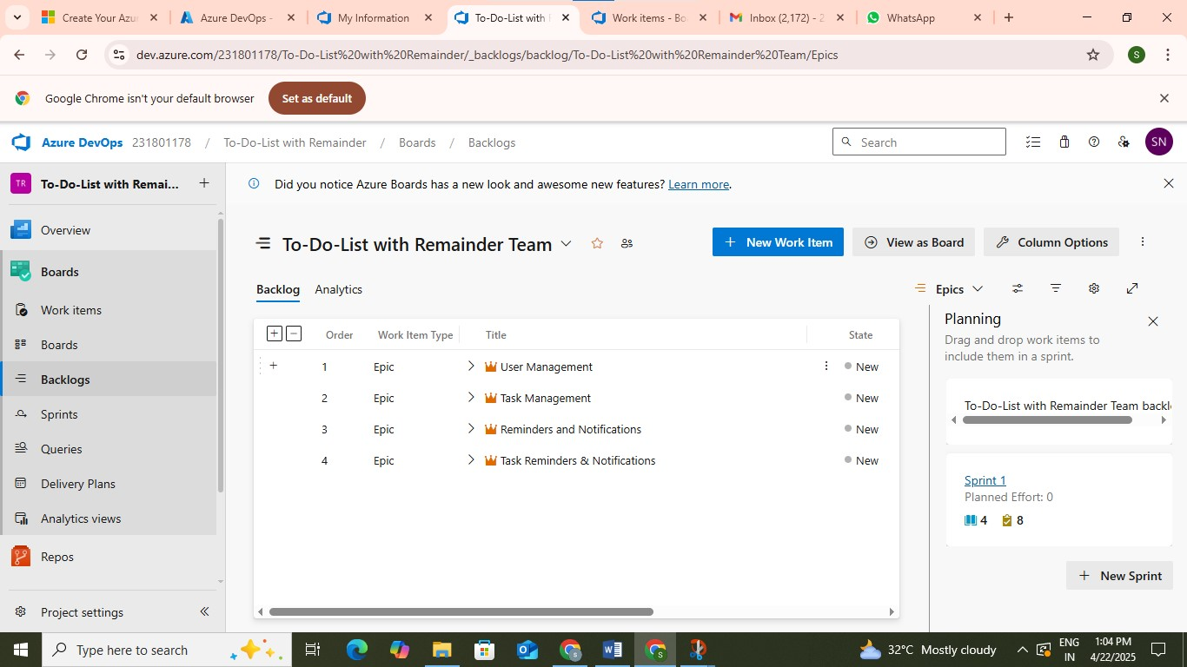

**2.Fill in Features**



**3.Fill in User Story Details**

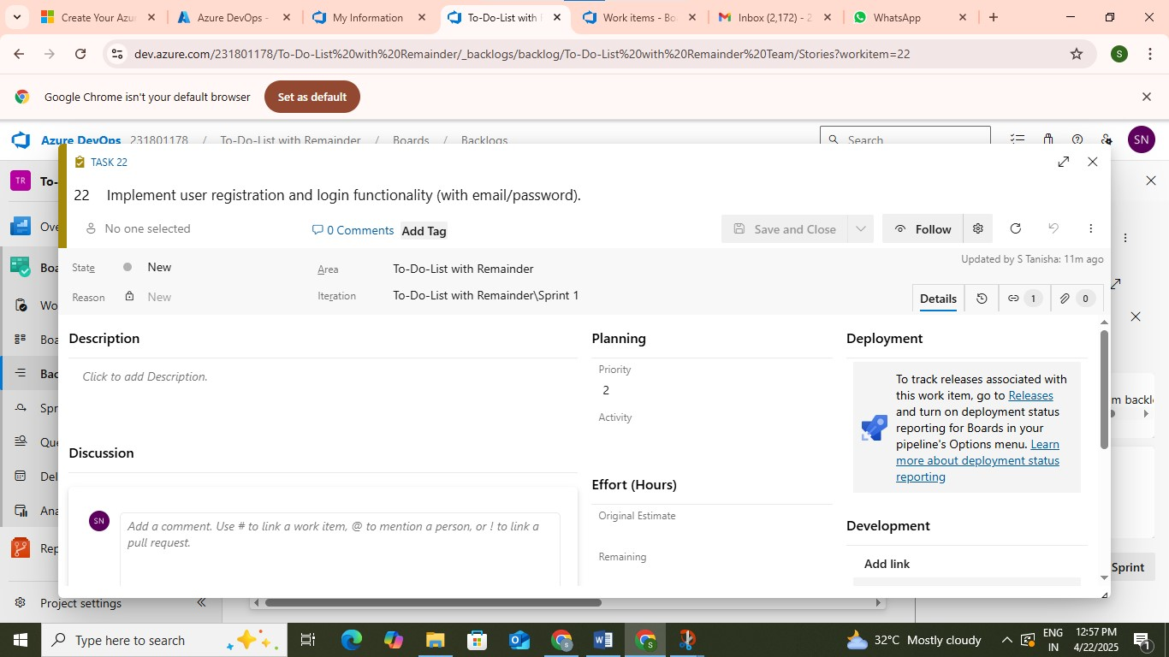

**Result:**

**Thus, the creation of epics, features, user story and task has been created successfully.**

|  |  |
| --- | --- |
| **EXP NO: 4** | **TEST PLAN ,TEST SUITES AND TEST CASE** |

**Aim:**

**To assign Test case ,Test suites and Test case specific sprint for the To Do List With Remainder Project.**

**Test Planning :**

**Test suites:**

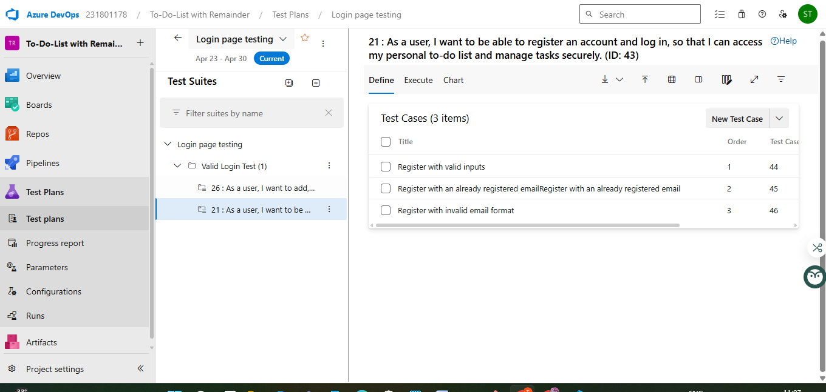

**Test cases:**

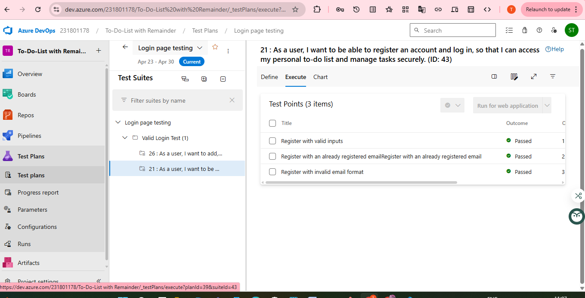

**Test Run:**

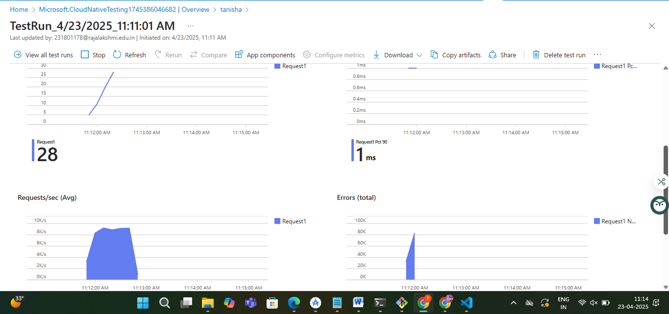

**Test Suites:**

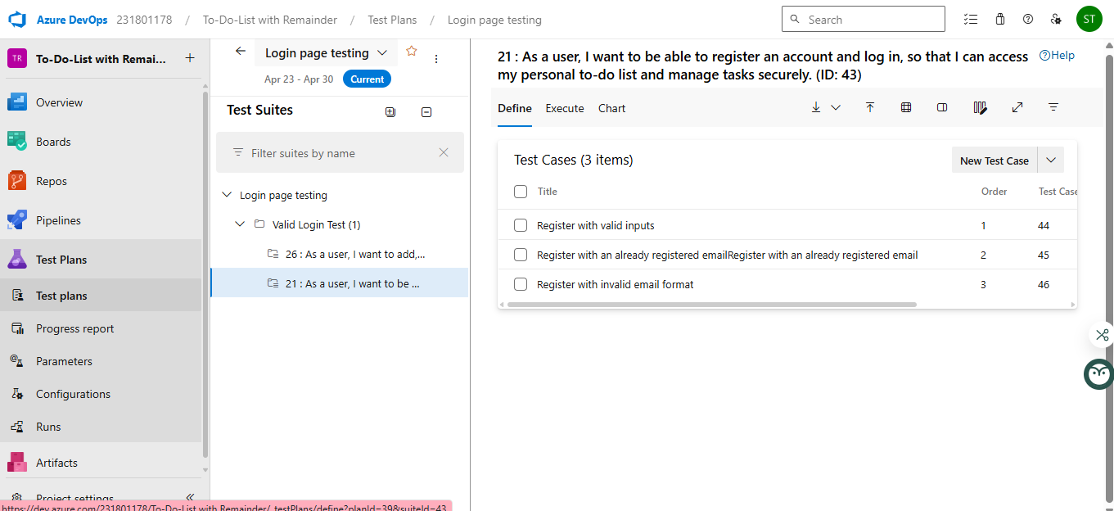

**Test Cases:**

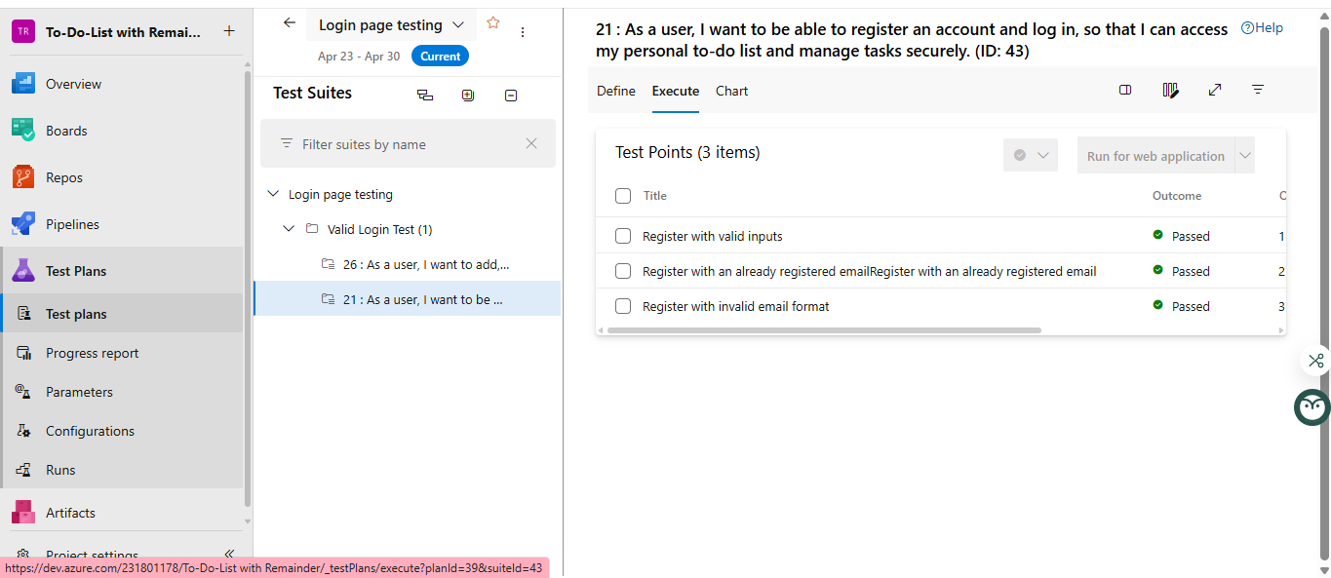

**Test Run:**

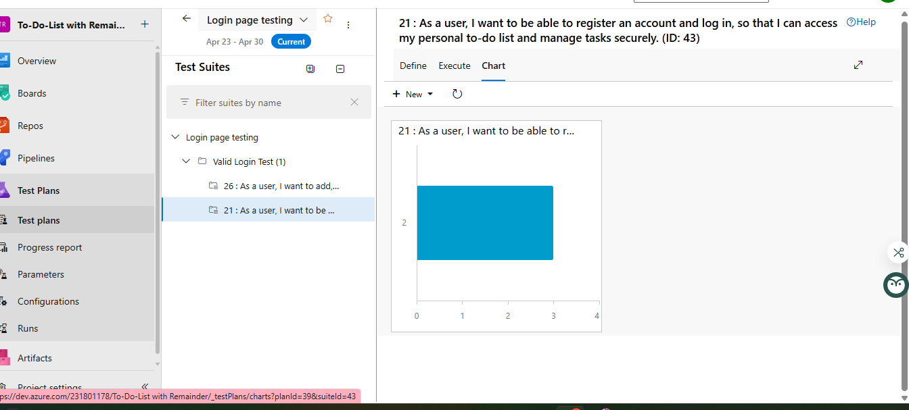

**RESULT : Thus , the Test plan ,Test suites and Test cases of the To Do List With remainder was executed Successfully**

|  |  |
| --- | --- |
| **EXP NO: 5** | **POKER ESTIMATION** |

**Aim:**

Create Poker Estimation for the user stories - Music Playlist Batch Creator Project.

**Poker Estimation**

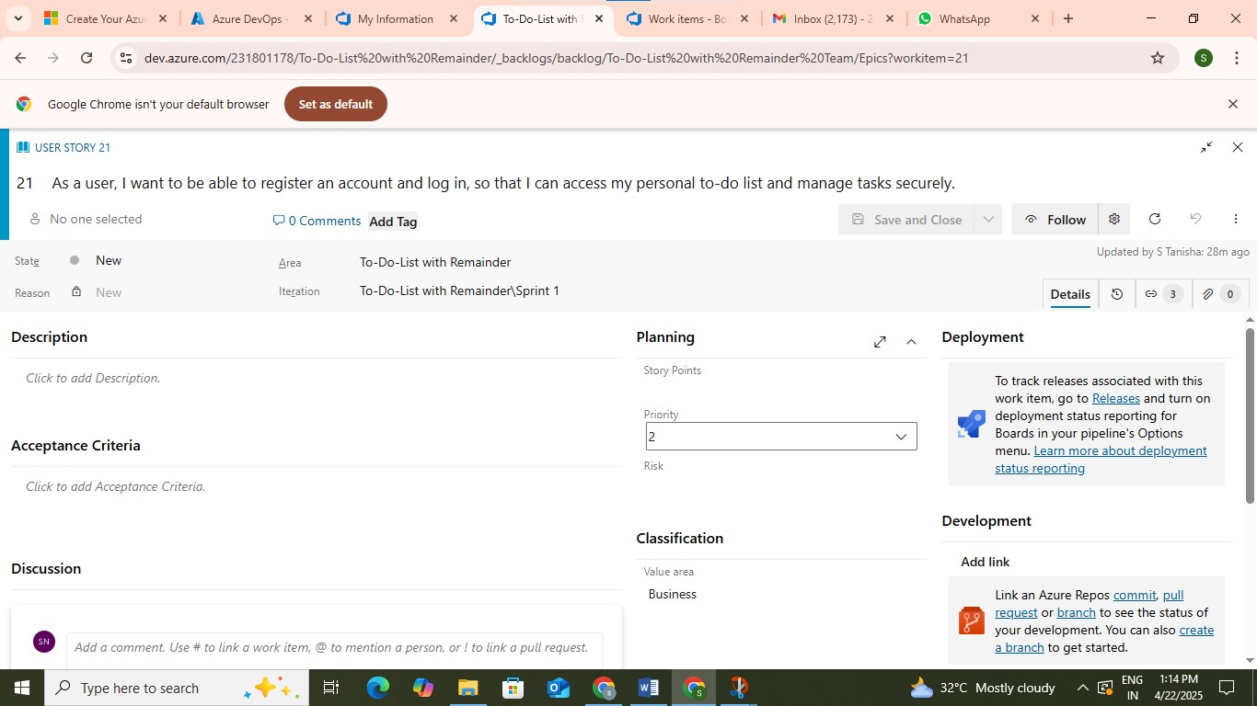

**Result: The Estimation/Story Points is created for the project using Poker Estimation.**

|  |  |  |  |  |  |
| --- | --- | --- | --- | --- | --- |
| **EXP NO: 6** |  | | | | |
|  | **DESIGNING CLASS AND SEQUENCE DIAGRAMS FOR** | | |  |
|  | **PROJECT ARCHITECTURE** |  |

**Aim:**

To Design a Class Diagram and Sequence Diagram for the given Project.

**6A. Class Diagram**

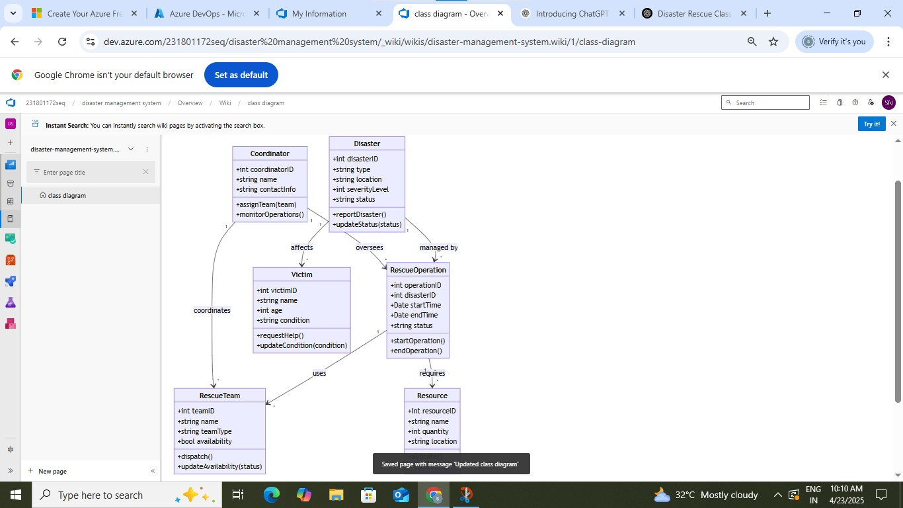

**6B. Sequence Diagram**

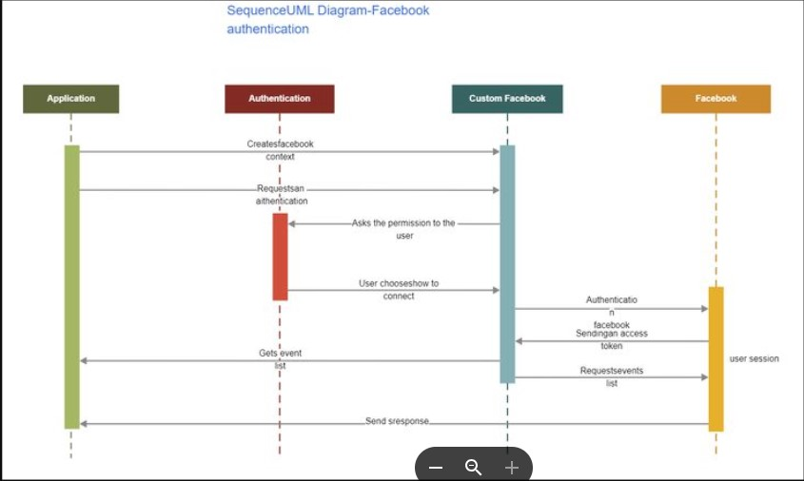

**Result:** The Class Diagram and Sequence Diagram is designed Successfully for the Music Playlist Batch Creator.

|  |  |  |  |  |  |
| --- | --- | --- | --- | --- | --- |
| **EXP NO: 7** |  | | | | |
|  | **DESIGNING ARCHITECTURAL AND ER DIAGRAMS FOR** | | |  |
|  | **PROJECT STRUCTURE** |  |

**Aim:**

To Design an Architectural Diagram and ER Diagram for the given Project.

**7A. Architectural Diagram**

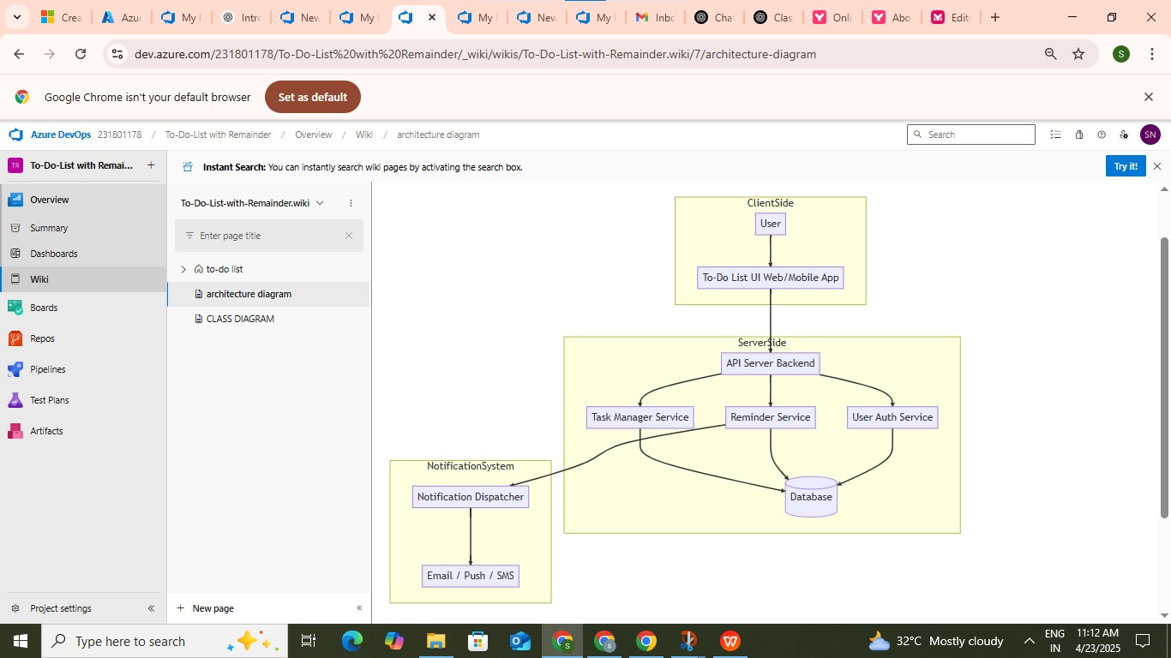

**7B.ER Diagram**

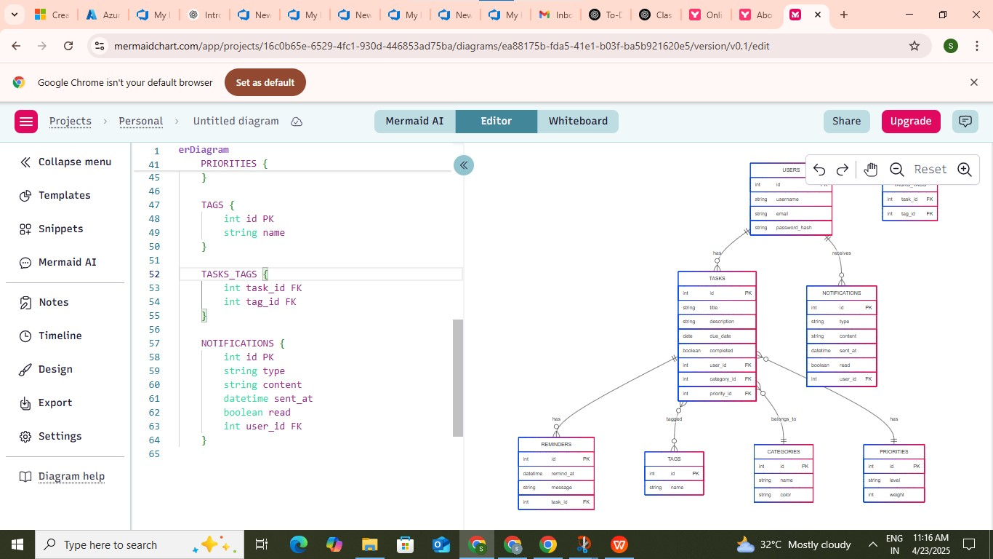

**Result:** The Architecture Diagram and ER Diagram is designed Successfully for the Music Playlist Batch Creator